2025-2026 ACADEMIC YEAR
9th
MİZANCI MURAT AİHL
9th GRADE 2nd Semester - 2nd Exam (Scenario 1)
Name / Surname: ________________________________ | Class: ______ Number: ______
Q1. Read the text and answer the questions. (20 points)
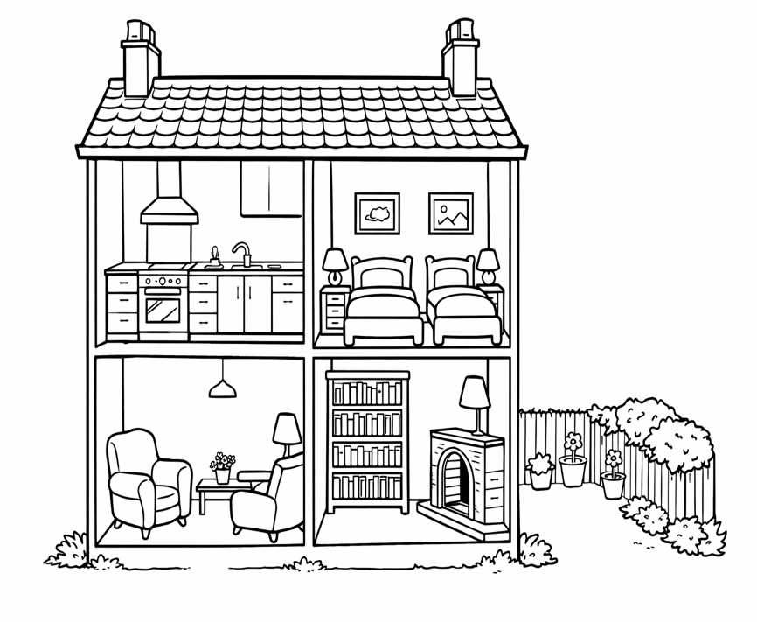

Our New Home

Hi! My name is Jack. Two months ago, my family moved to a detached house in Sunnyville. It has two floors. On the ground floor, there is a large kitchen, a dining room, and a small bathroom. The kitchen is my father’s favourite room because he enjoys cooking. There is a modern oven and a large refrigerator in it. The dining room has a big table and six chairs. Upstairs, there are three bedrooms and a bathroom. My bedroom is opposite my sister’s room. In my room I have a desk, a bookshelf, and a comfortable bed.

We also have a small garden in front of the house. My mother likes planting flowers there. Our neighbourhood is peaceful and friendly. There is a supermarket near our house and a playground acroos the street.
a) What type of house does Jack live in?
___________________________________________________________________________
b) Whose favourite room is the kitchen?
___________________________________________________________________________
c) Where is Jack’s bedroom?
___________________________________________________________________________
d) How many floors does the house have?
___________________________________________________________________________
e) what is there in front of the house?
___________________________________________________________________________
Q2. Look at the information card and write a paragraph about the food festival. (20 points)
Use Simple Present Tense. Write at least 5 sentences.
___________________________________________________________________________
___________________________________________________________________________
___________________________________________________________________________
___________________________________________________________________________
___________________________________________________________________________
GREENVILLE INTERNATIONAL FOOD FAIR
Festival Name | Sunshine International Food Fair
Place | City Square, Newyork
Traditional Dishes | mantı, köfte, stew
International Dishes | tacos, curry, pizza
Popular Taste | spicy and savoury

Q3. Read the text and answer the questions. (20 points)
Protecting Rainforests
Rainforests are very important ecosystems. They are home to thousands of animals and plants. These forests help produce clean air and keep the climate balanced. However, deforestation and forest fires threaten their future. Cutting down trees destroys many animal habitats. In the past, rainforests covered much larger areas. Today, many environmental groups work hard to protect them. They plant new trees, organise campaigns and educate people about nature. Everyone should help protect forests by reducing waste and using resources carefully.

a) What are rainforests home to?
___________________________________________________________________________
b) Why are rainforests important?
___________________________________________________________________________
c) What threatens the future of rainforests?
___________________________________________________________________________
d) What do environmental groups do to help?
___________________________________________________________________________
e) What should people do to protect forests?
___________________________________________________________________________
ŞEYDA BEYDE NAİME OLCAR İSA PULAT
İngilizce Öğretmeni İngilizce Öğretmeni Okul Müdürü OKUL MÜDÜRÜ
# | Situation | Clue
1 | Sarah packed her suitcase. She __________ (visit ) her grandparents next weekend. | plan
2 | Oh, I forgot my notebook at home. I __________ (lend) you mine. | spontaneous decision
3 | Look at those grey clouds! It __________ (rain) soon. | evidence
4 | I think people __________ (use) more electric cars in the future. | prediction
5 | Tom promised his teacher. He __________ (finish ) his project on time. | promise

Q5. Read the situations and complete the sentences with "will" or "be going to". (20 points) (20 points)
Write a sentence for each rule. Use must / mustn't / should / shouldn't and give a reason.

1. _____________________________________________________

2. _____________________________________________________

3. _____________________________________________________

4. _________________________________________________________

5._________________________________________________________
CITY LIBRARY
VISITOR RULES
X | Talk loudly
X | Eat food near the books
✓ | Return books on time
✓ | Keep the library clean
X | Use mobile phones during study time

Q4. Look at the visitor rules and write sentences. (20 points)

